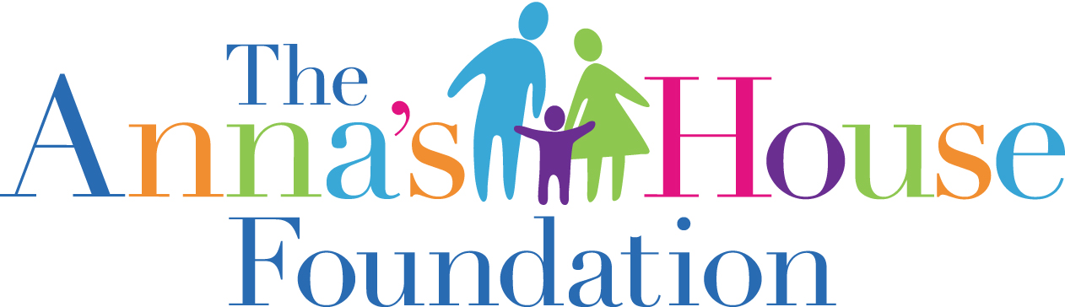

PERFORMANCE AND QUALITY IMPROVEMENT REPORT
JULY – SEPTEMBER 2021

VISION

Anna’s House Foundation desires to offer a future of hope and faith to foster children and foster families by providing housing, support, training, and resource in a Christian community setting.

MISSION

The Anna’s House Foundation is a faith-based organization whose mission is to provide immediate, stable and loving homes for children in Oklahoma state custody.

INFORMATION PROCESS

Anna’s House Foundation received information through bi-annual foster parent surveys, case reviews, staff exit interviews, foster parent exit interviews and audits. Information received is compiled, reviewed, and analyzed by staff, PQI team and Board of Directors with a goal of communicating successes and needed changes back to stakeholders.

FOSTER CARE PROGRAM
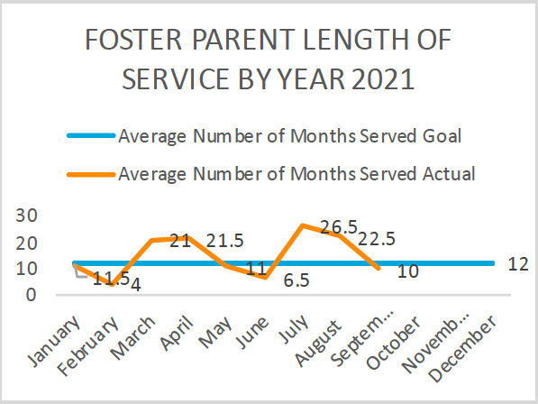 | Directly tied to our need for new foster homes is a goal of maintaining existing foster home. The goal of AHF is to reach 24 months of services by all foster homes. To reach this goal we must evaluate the number home closures, their length of service and their reason for closure.  As of September 2021 the average length of service for AHF foster families was 10 months served.
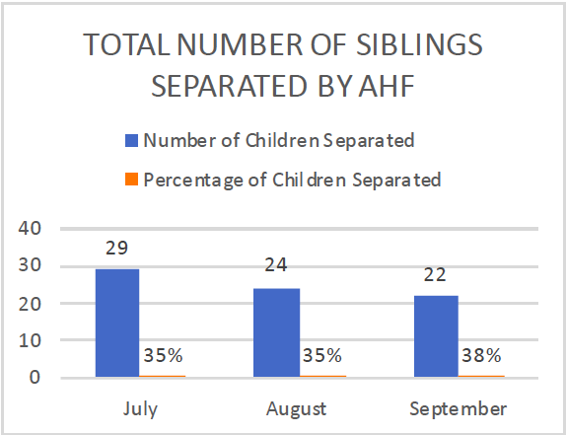 | AHF strives to provide an environment where foster children are not separated from their siblings. Our goal is that the percentage of sibling groups where all siblings are placed together shall be at least 65%.  For Q3 - 62% of children placed by AHF are placed with one or more of their siblings.
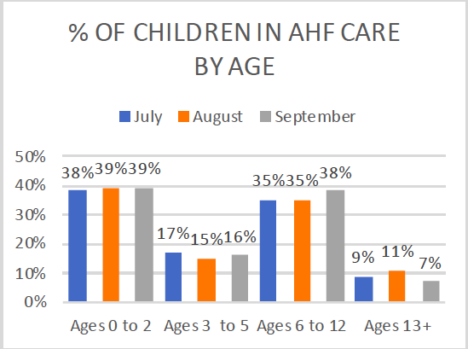 | AHF aims to proportionally serve foster children based on the age needs of child in OKDHS custody.  AHF served an equivalent proportion of children based on age of children in OKDHS custody during the months on July - September 2021.

FINANCIALS
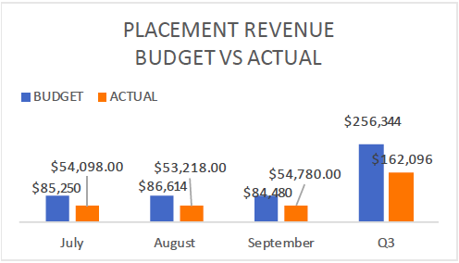 | AHF creates an annual budget or written plan of financing with projects sufficient funds to enable them to carry out their defined purpose and provide proper care to foster families and children.
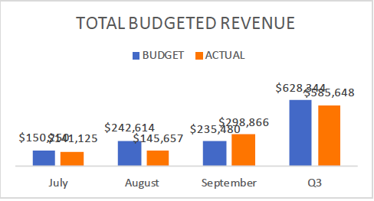 | The largest variance in revenge vs expenses is the difference in placement contract and grants. There is an anticipated $35,000 grant to appear in the 4th quarter.

CERTIFICATION

The need for foster home exceeds the number of homes available in our state. The goal of this approach is to increase the number of new and experienced foster homes resulting in more children served.

AHF set our certification goal of 24 families, and currently had a total of 3 newly certified families.

TANGIBLE RESOURCES
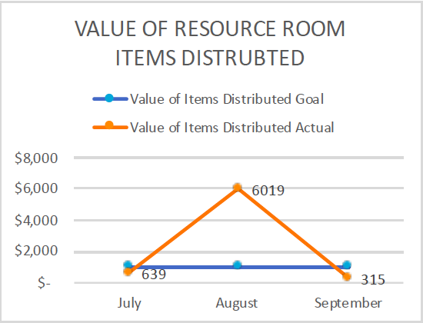 | Well supported families also have lower rates of maltreatment in care. The foal of this approach is to use the most appropriate forms of support to meet the families financial, emotional and spiritual needs resulting in longer tenures of service.

